Techniques for controlling weeds from https://www.environment.nsw.gov.au/cpp/WeedRemovalFactsheets.htm

The following information describe simple weed removal techniques which can be used in bush regeneration projects:

Control of small, hand-pullable plants (PDF - 88KB)
This fact sheet outlines methods for removal of small soft weeds (eg. fleabane, crofton weed, small grasses) and seedlings of any weeds (including privet, lantana and moth vine).
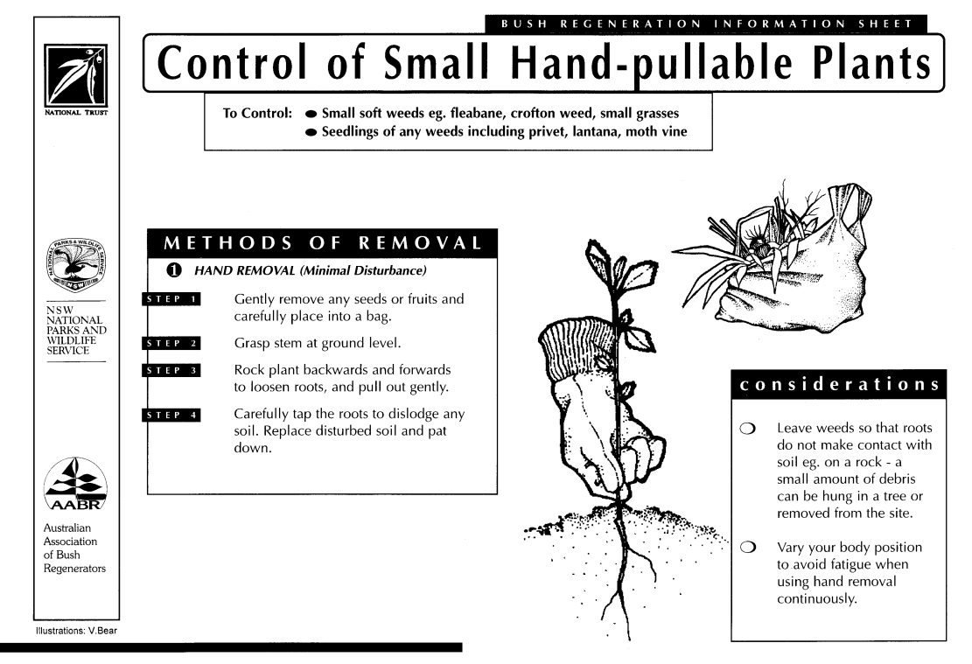

Control of vines and scramblers (PDF - 99KB)
This fact sheet outlines mMethods for removal of vines such as balloon vine, morning glory, honeysuckle, cape ivy, jasmine, madeira vine and blackberry.
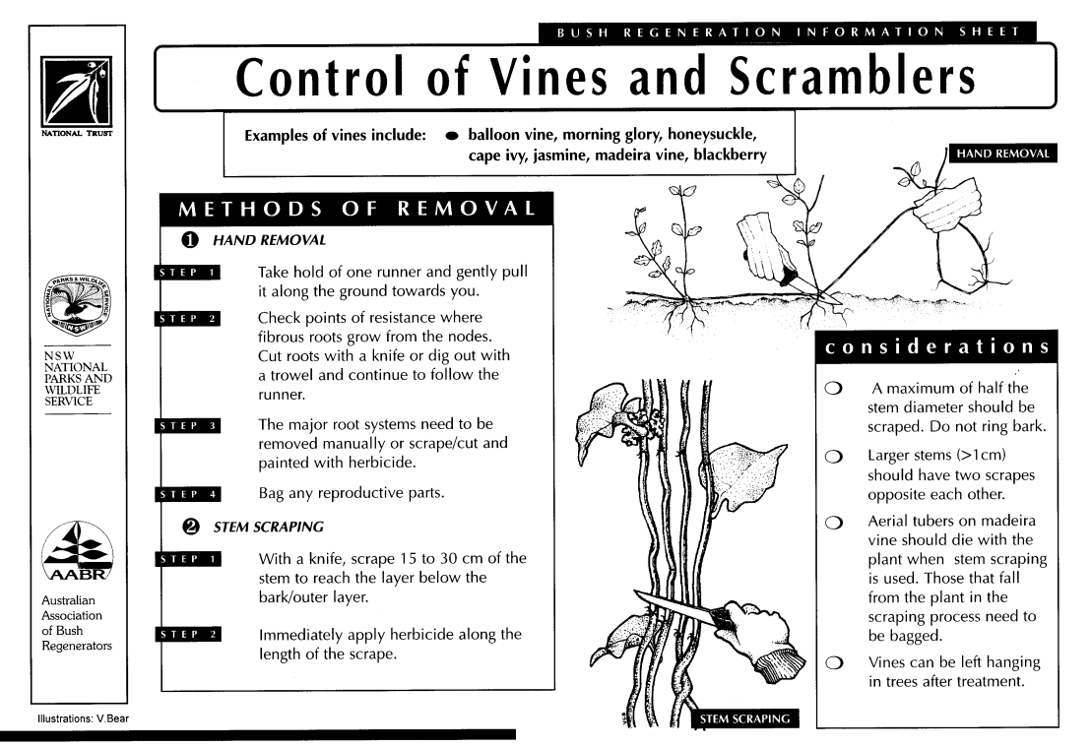

Control of weeds with underground reproductive stems (PDF - 118KB)
This fact sheet outlines methods for removing weeds with tap roots (eg. catsear, dandelion), rhizomes (eg. asparagus fern, ginger plant), bulbs and corms (eg. oxalis, onion weed, watsonia, freesias, montbretia) and tubers (eg. madeira vine, arrow head vine).
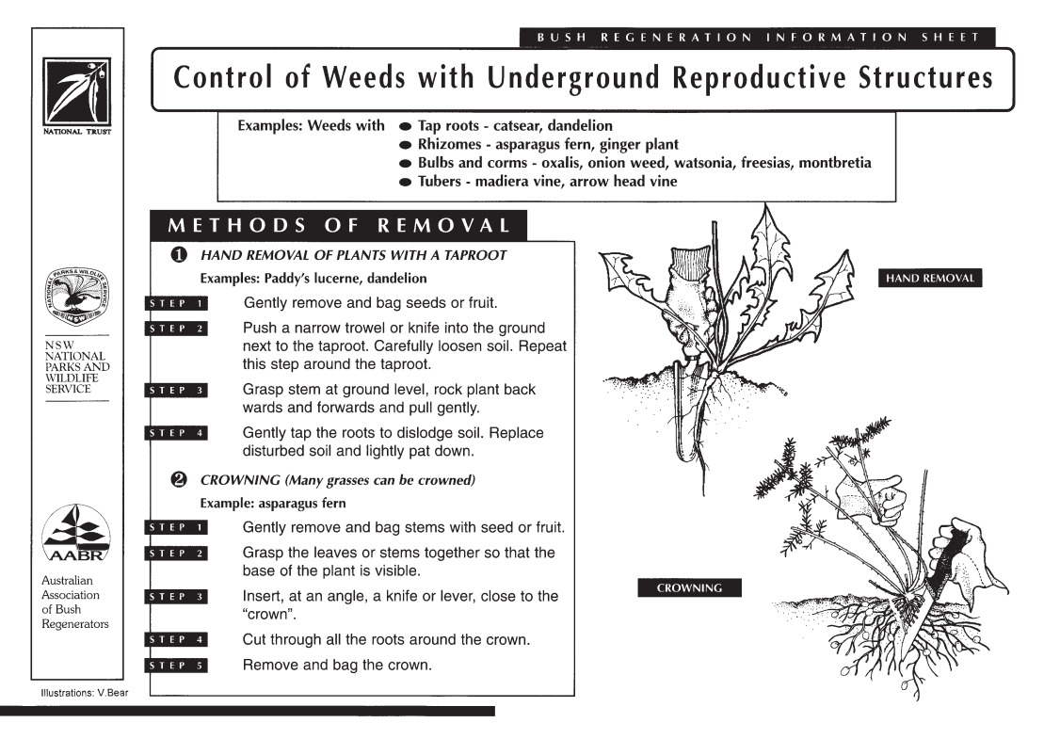

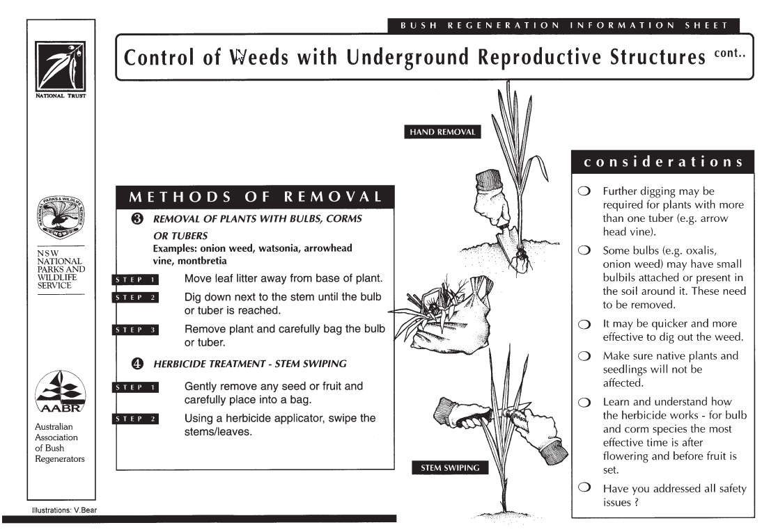

Control of woody weeds (PDF - 114KB)
This fact sheet outlines methods for removal of woody weeds such as lantana, bitou bush, cotoneaster, privet, camphor laurel, Mickey Mouse bush (ochna) and cassia/senna.
