Weeds

A weed is a plant growing where it is not wanted, weeds in agriculture and those that invade bushland are difficult and costly to control.

In 2017 a Regional Strategic Weed Management Plan 2017-2022 (1.28mB PDF) was released for the North Coast Region (the Plan). The Plan was prepared in accordance with the Biosecurity Act 2015 which repeals the Noxious Weeds Act 1993. It outlines strategies and actions to achieve the goal of shared responsibility for weed management across all tenures. It will achieve this through a range of regulatory tools and a General Biosecurity Duty, more information is available from, Tweed Shire's weed control authority, Rous County Council website (see RH box for link).

Click here (161kB PDF) to view a list of weeds that have been identified by Rous County Council as high priority biosecurity risk species in the Plan for the Far North Coast region. A second document listed in the box also lists:
- Weeds of National Significance (WONS) identified under Federal legislation;
- plants included on the National Environmental Alert List (external link)
- other local environmental weeds that can impact on bushland and farmland; and
- weed species previously declared as Noxious but not recorded in the Tweed.
Many of the species listed in these documents are garden escapees and residents of the Shire can assist in the maintenance of healthy bushland and in reducing the cost of controlling inappropriate species through the choices that they make in their own gardens. To assist residents’, publications such as the Bushland Friendly Nursery Scheme: Environmental weeds and native alternatives and My Local Native Garden are available through Council’s Natural Resource Management Unit.

Where can I find out more information about weeds?
- Weed resources Far North Coast Weeds https://www.rous.nsw.gov.au/cp_themes/default/page.asp?p=DOC-OBY-34-28-00
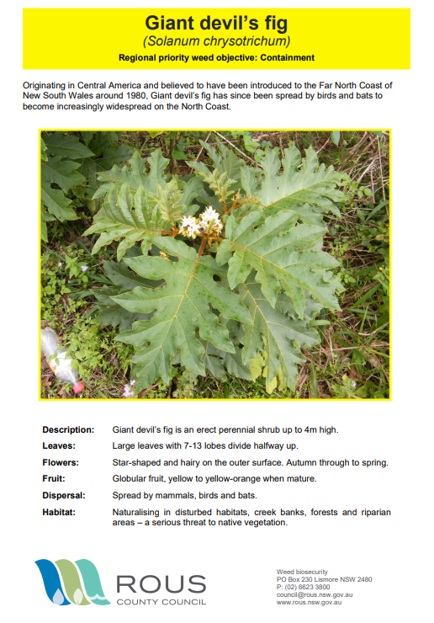

- NSW DPI Weed Wise
https://weeds.dpi.nsw.gov.au/
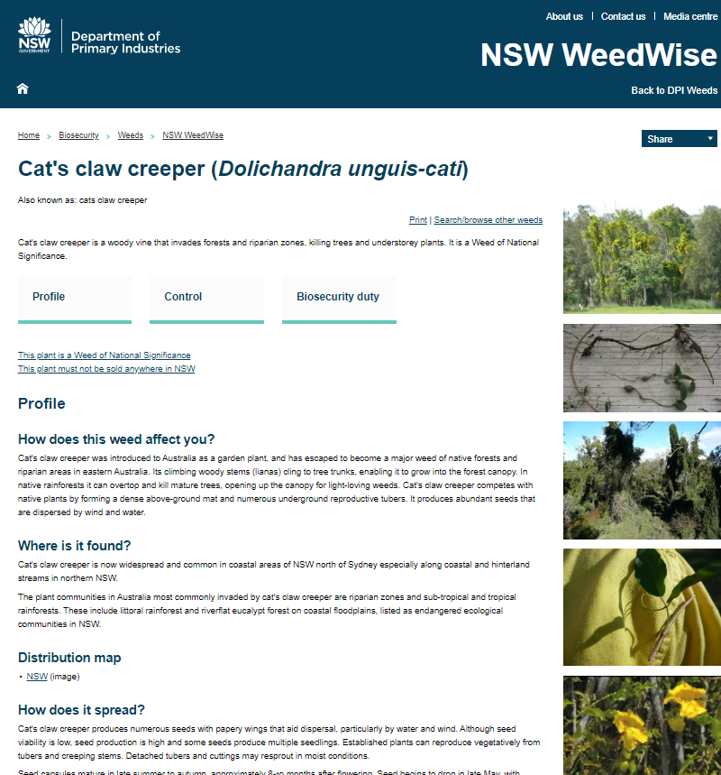
- Brisbane City Council
https://weeds.brisbane.qld.gov.au/search/weeds
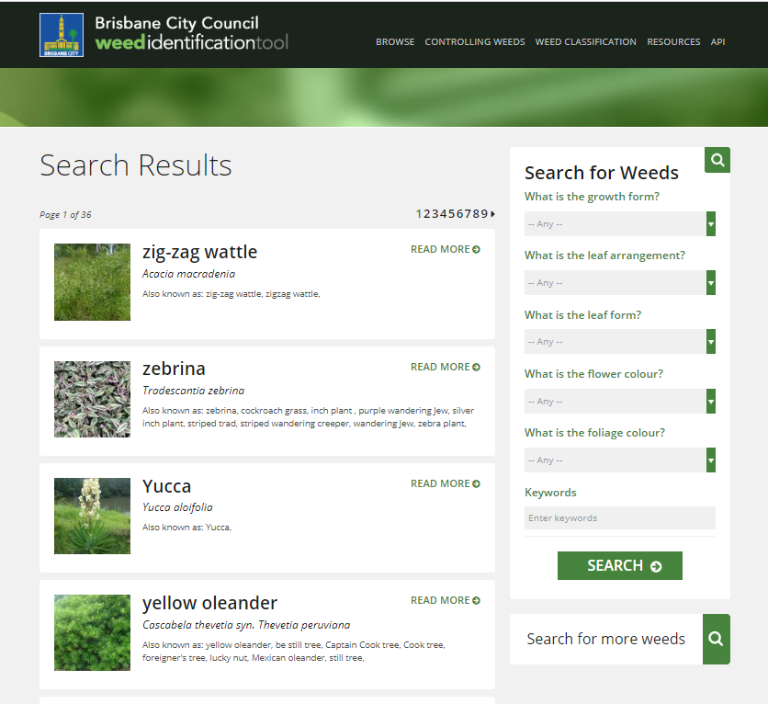
- Tweed Shire Council Weeds

- Tweed Landcare (Grassroots Gazette newsletter)
- 