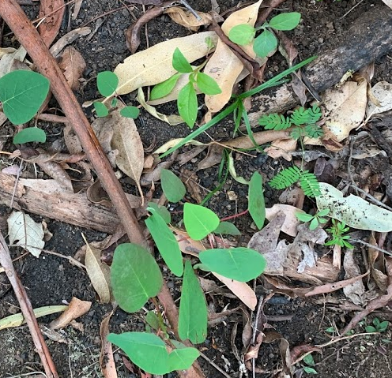
What is bush regeneration?

Bush regeneration is the practice of removing weeds from the bush so that the native plants get a chance to come back on their own. It depends on the in-built resilience of native plants to sprout from the seedbank or regenerate quickly when the environment is favourable to their growth. By removing the weeds this tips the balance in the favour of the native plants to outcompete the weeds and eventually form a more stable ecosystem that is resilient to small disturbances and seed drop by birds.

Bush regeneration usually applies to degraded bush that may have been damaged as a result of logging, grazing, cropping, clearing,road making, urban sprawl, flooding events, fire, landslides and cyclones etc.

Many of the weeds were introduced to Australia from South America, Asia and South Africa as garden ornamentals, pasture species and sources of food. Others were brought in as packing material, in soil, manure or livestock feed. Some weed seed was brought in by animal vectors, blew in on air currents or washed up on the shore. In favourable conditions, without natural predators and plenty of vectors to spread the seed, the weeds have grown unchecked.

What are the main principles of bush regeneration?
The original term ‘bush regeneration’ was first coined by Joan and Eileen Bradley from Mosman, Sydney who wrote the book “Bringing Back The Bush” which provides a great insight to the beginnings of the practice which is almost enlightening once experienced as it creates a healing relationship between the bush and the practitioner.
The Bradley Sister’s principles: “Work From The Good Bush Out,” “Minimal Disturbance,” and “Allow Regeneration to Dictate The Rate of Weed Removal,” still stand today (pers.comm Iam Walker 10th October 2019)

The following points should be considered as part of any restoration program:
- Retain- remnant indigenous vegetation
- Regenerate- where there is any potential for natural regeneration
- Replant- only where there in no regeneration potential

Do you even need to plant? https://aabr.org.au/images/stories/resources/posters/NaturalRegeneration060612.pdf
