Bush Regeneration is the rehabilitation of land from a weed affected or otherwise degraded area to a healthier community of native plants and animals. From bushlands to coastal dunes or rainforests or wetlands, the aim is to restore and maintain the ecosystem's health by helping the natural regeneration of indigenous plants.

Site Action Plans
file:///C:/Users/KimStephan/Downloads/Site_Action_Plan_Guidelines_(Bush_Futures).PDF

Further reading
1.The South East Queensland Ecological Restoration Framework provides a code of practice, guidelines and a practical manual for ecological restoration that has become a standard reference for practitioners in SE Queensland and the Northern Rivers of NSW.
Chenoweth EPLA and Bushland Restoration Services (2012) South East Queensland Ecological Restoration Framework: Manual. Prepared on behalf of SEQ Catchments and South East Queensland Local Governments, Brisbane. Link to dowload https://hlw.org.au/download/seqecologicalrestorationframeworkmanual/
Link to pdf file:///C:/Users/KimStephan/Downloads/SEQERFmanualpart1.pdf
file:///C:/Users/KimStephan/Downloads/SEQERFmanualpart1.pdf
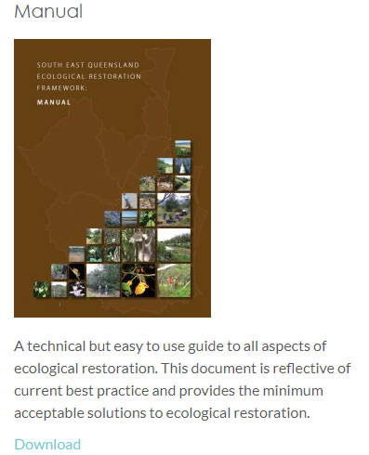

2. Subtropical Rainforest Restoration: a Practical Manual and Data Source for Landcare Groups, land Managers and Rainforest Regenerators, produced by the Big Scrub Rainforest Landcare Group, also contains a wealth of information relating to ecological restoration of subtropical rainforest. (Visit: www.bigscrubrainforest.org.au/online-store/subtropical-rainforest-restoration )
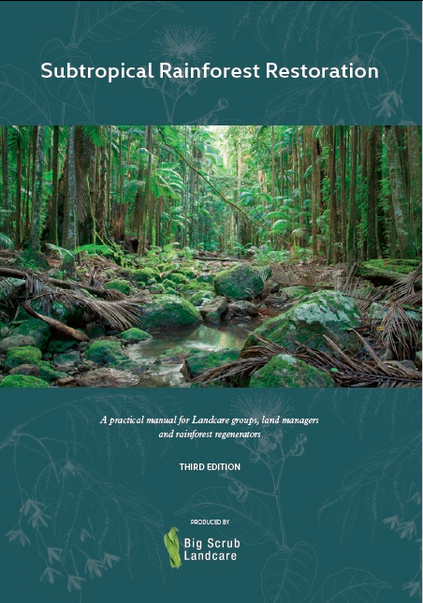

N.B. Some of these books and other plant identification books are stocked at the Caldera Environment Centre

· Trees and Shrubs (2nd edition) and Rainforest Plants (Harden, Williams and Mc Donald) 2007
· Rainforest Climbing Plants (2nd edition): a field guide to their identification in Victoria, New South Wales and subtropical Queensland using vegetative features (Harden, Williams and McDonald) 2007
· Mangrove to Mountains- a field guide to the native plants of south-east Queensland (2017)
· Common Weeds of Subtropical Rainforests of Eastern Australia (Big Scrub Rainforest Landcare Group (2008)
Websites for advice on bush regeneration
See Australian Association of Bush Regenerators (NSW) Inc. website for detailed information: www.aabr.org.au

https://www.tweed.nsw.gov.au/BushlandRegeneration

