Tools and Equipment
There are a number of tools and equipment that Bush Regenerators use. The most commonly used tools include a sharp knife, secateurs, folding hand saw, loppers, trowel, cordless drill (with 10mm auger drill bit), and squeeze or spray herbicide bottle.
Some of these can be kept in a belted tool kit (see diagram below). If you want to get more serious you can get a battery operated electric or petrol chainsaw.
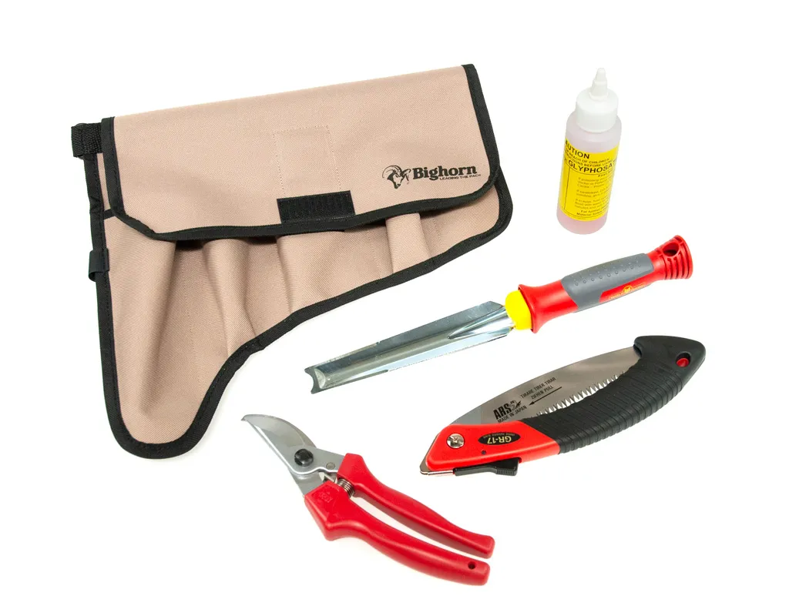
https://www.arborgreen.com.au/product/2457-bush-regenerators-kit-polyester-with-tools#images-2457-1

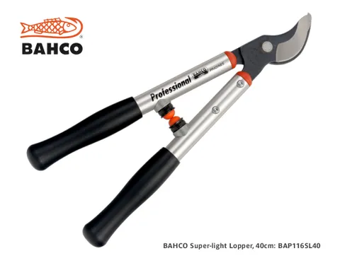

To herbicide or not to herbicide

Most bush regenerators use herbicide to assist with weed control, although some individuals and ‘Care’ groups choose to go chemical free. Chem free groups use manual or mechanical methods of weed control such as hand pulling, digging out the root base, covering weeds (e.g., black plastic/old carpet), chainsawing or heavy machinery to remove large root masses.

Herbicide is a valuable tool for treating certain types of weeds e.g., large trees, rampant vines, and persistent weeds like glory lily or giant devil’s fig. It is also useful in tackling densely infested sites and areas prone to erosion.

The most widely accepted herbicide for bush regeneration is glyphosate. It is a non-selective knockdown herbicide. Like all herbicides it should be treated with extreme care in line with the directions on the label. Please note that laws govern the use of herbicides. Each must be registered for use on particular weeds and at particular dosage rates.
Many weeds treated in bushland are not listed for registered use on the label. Permits for ‘off label’’ use must be obtained from the Australian Pesticides and Veterinary Medicines Authority

How does glyphosate work?
Glyphosate is usually applied to leaves, although it can be introduced directly into the sap through tree injection, frilling or the cut stump method. When applied to the leaves, glyphosate penetrated the waxy cuticle and enters the foliage where it travels through the plant’s internal transport system- mainly in the phloem cells nut also in the water-carrying xylem cells. The herbicide moves through the whole plant, including the food storage and reproductive tissue below the ground.

Herbicide can be applied in a number of ways:
- Sprayed on leaves
- Cut, scrape and paint
- Frilling or chipping
- Tree injection
These methods are described in the Techniques for Controlling Weeds section of the website.

Using herbicide is fairly simple, however there are a number of rules for successful results:
- Apply herbicide when the plant is actively growing
- Apply herbicide when the plant is most receptive- early morning or late evening in summer, around midday in winter. These are the times when the plants’ stomates are open and the herbicide can penetrate more easily.
- Do not apply herbicide when the plant is under stress e.g., extreme heat, frost, drought, disease, waterlogged soil
- Do not re-apply herbicide too soon after the initial treatment. Wait until the plants begins actively growing again
- Do not spray if rainy or windy weather is expected in the next few hours
- Leave plants in the ground until the roots have died off
- Make sure herbicide doesn't fall on non-target plants. Hand weed around native first and protect from spray using plant pots, buckets etc
- Do not allow herbicide to become contaminated with dirt. It may reduce its effectiveness
- Do not mix chemicals unless it says so on the labels

